Driving High Engagement – The Alignment Race
Comprehensive Mobilization of Your Teams and Alignment with the Business Goals

Target | - The Engagement Race is a very innovative and effective workshop format to vitalizes, mobilizes and realigns your company.  - It enables you to firmly establish your strategic intent in your organization. As well, together with your teams you can solve acute problems in a highly efficient and time saving manner: e. g. “how can we significantly improve our sales processes and win more deals?” or “how can we smoothly communicate the planned price increase?”  - The Engagement Race is scalable and can also be applied to multiple and international teams. This critical mass generates a sustainable and dynamic process for the target driven development of your teams and organisation.
Content | - The Engagement Race is set up like a Formula 1 Race with challenging “Pit Stops”, which are designed specifically to solve your major business problems.  - In these „Pit Stops“, the participants face up to current or future business challenges driven by changing customer needs or aggressive competitors.  - The topics are always adapted to your individual business, needs and targets.  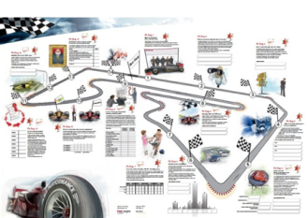
Method | - The Engagement Race runs at high speed. It is competitive and  very interactive.  - It creates a supportive learning atmosphere and it facilitates  the problem solving process.  - The participants work under a positive tension, while intensively  discussing winning business ideas or removing costly process barriers.  - Typically, a Race consists of 4 to 12 teams with 5 members each.  - The mix is cross-functional and cross-locational.  - It can be organized simultaneously at multiple international locations.
Preparation | Interviews of representatives from different functions and hierarchy levels to adapt the „Pit Stops“ to your business needs.
Sustainability | The Engagement Race finally results in working groups, which will drive the implementation of the Race outcome – supported by the management.
Target Group | - The Engagement Race is targeted at all employees who are required to solve the selected business problems.  - The management is actively involved in the Race and will benefit from the intense dialogue with their staff about individual perceptions, business challenges and promising solutions.
Duration | One day.  Prior, the participants will be tuned to the Race by a targeted online questionnaire.

In cooperation with KeyLargos GmbH

